Applicant: M.Kumarasamy College of engineering No. of Sheets: 4

Application No:  Sheet No: 1 of 1

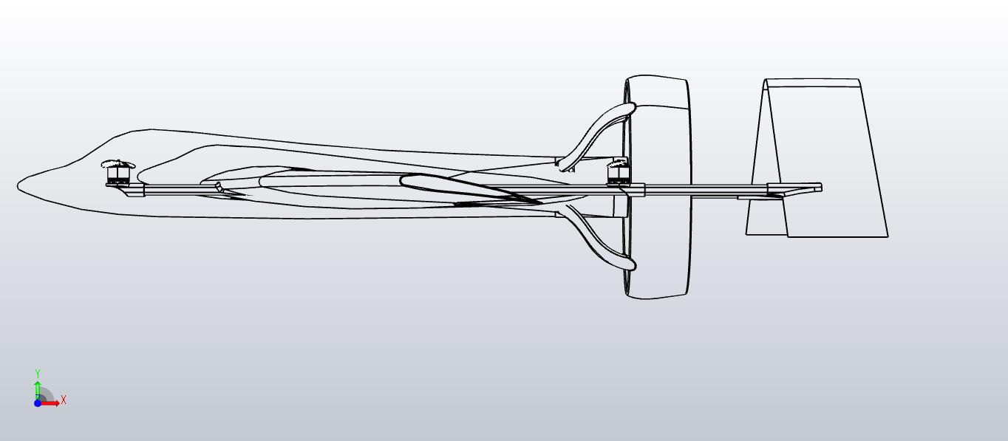

Figure 1 Front View

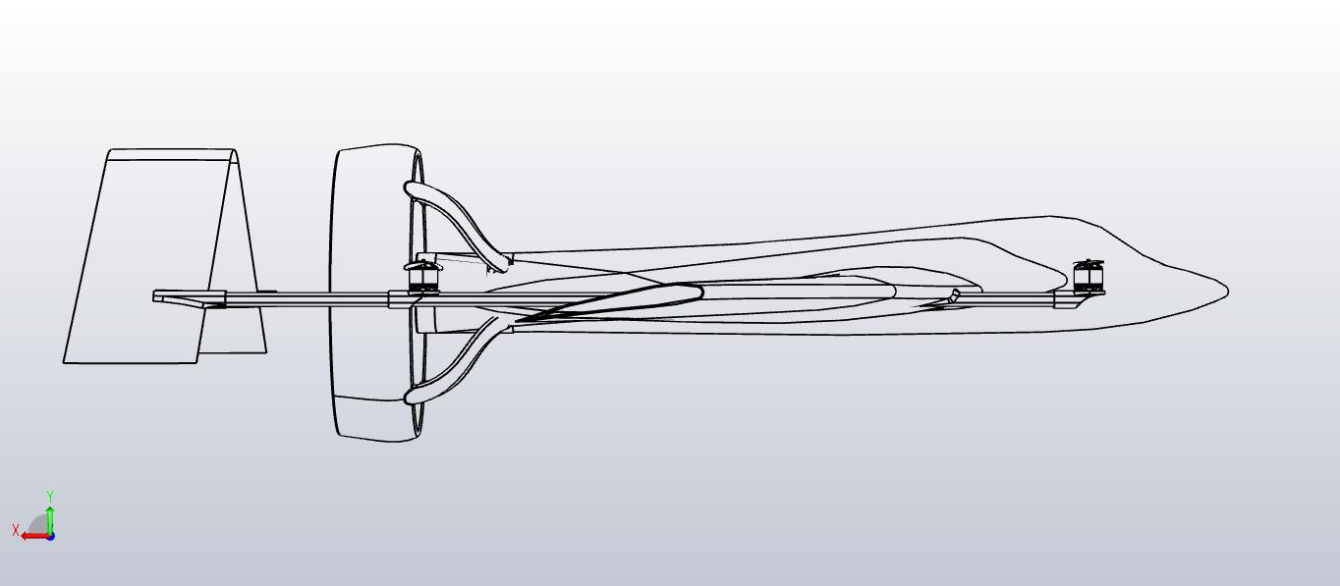

Figure 2 Back view

**Signature of Applicant**

Applicant: M.Kumarasamy College of engineering No. of Sheets: 4

Application No:  Sheet No: 2 of 3

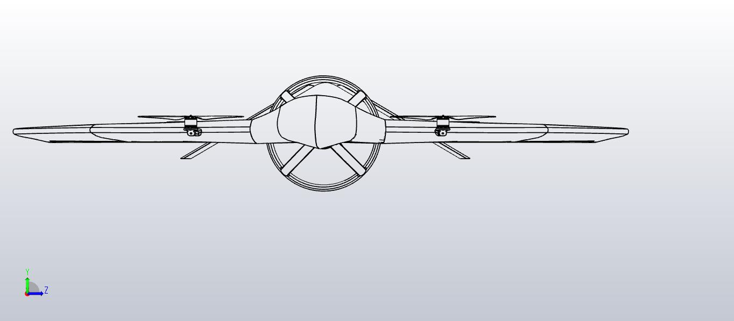

Figure 3 Left Side view

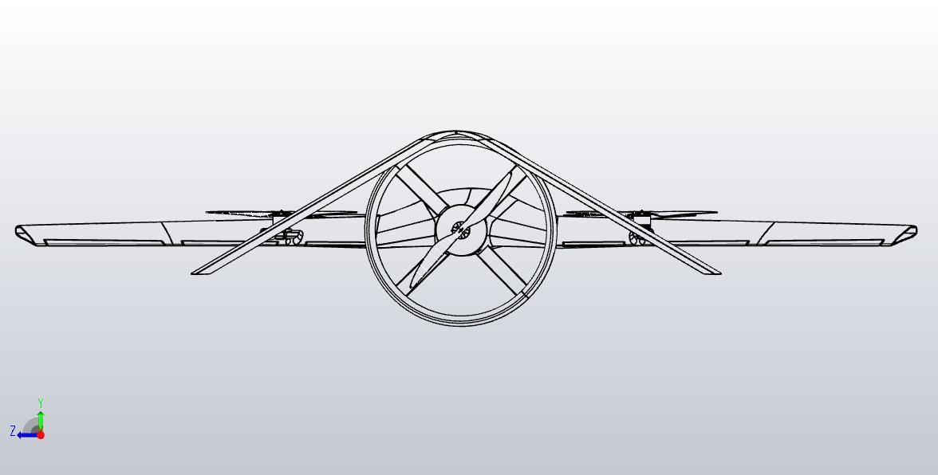

Figure 4 Right View

**Signature of Applicant**

Applicant: M.Kumarasamy College of engineering No. of Sheets: 4

Application No:  Sheet No: 3 of 3

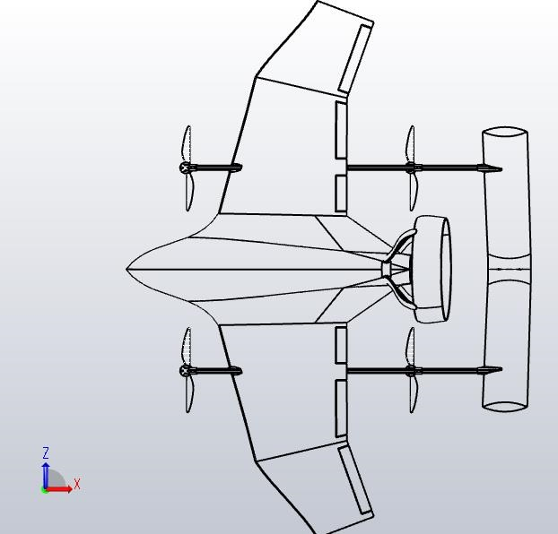

Figure 5 Bottom View

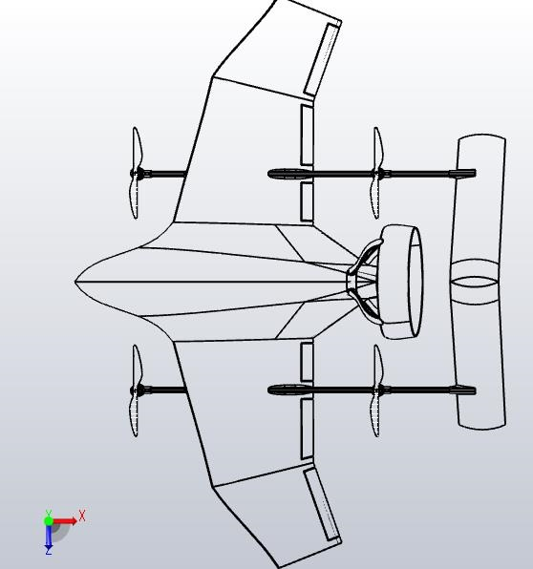

Figure 6 Top View

**Signature of Applicant**

Applicant: M.Kumarasamy College of engineering No. of Sheets: 4

Application No:  Sheet No: 4 of 4

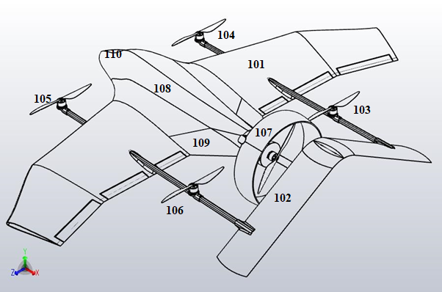

Figure 7 Isometric view

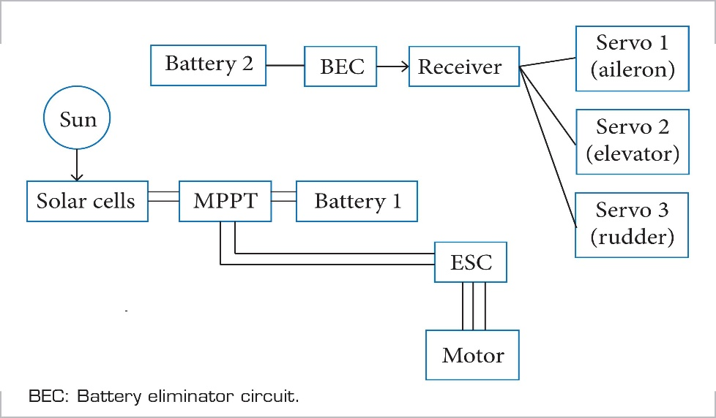

Figure 8 Overview of proposed system

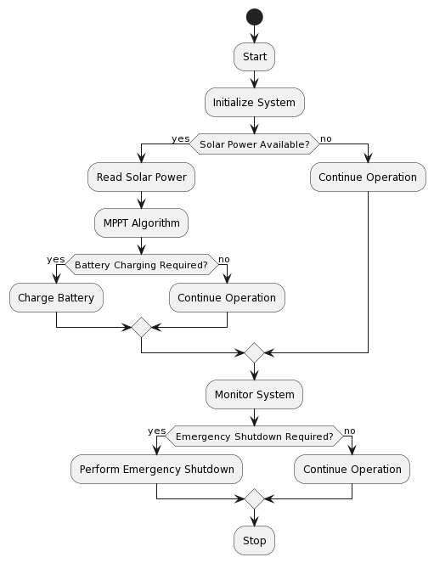

Figure 8 MPPT Algorithm